MASTERING 8 DIMENSIONS OF EXCELLENCE:
How to Align Strategy, Culture, Customer Experience & Measures of Success
2-Day Workshop

SUMMARY
This workshop provides a powerful, elegantly simple framework with new tools for dramatically improving organizational performance, customer success and cultural transformation. The content integrates and transcends practices such as Lean Six Sigma, Voice of Customer, ISO 9001, Baldrige National Award Criteria and related methods. Your award-winning instructor and best-selling author, Robin Lawton, uses an interactive, jargon-free style to deliver the innovative new mindset and tools that are perfectly suited to everyone in a knowledge-intensive enterprise. You will see significant results others have achieved rapidly, helping you apply insights and content to your own situation during the session.
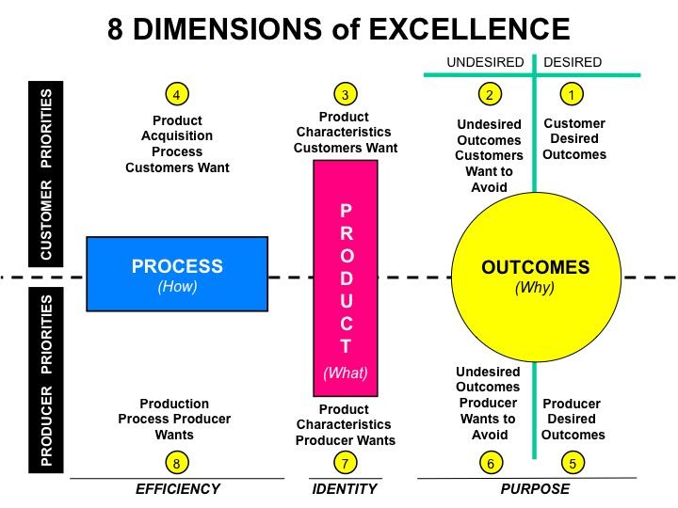
Change leaders like you have high expectations, a vision of the possible and urgency to engage others. Join this stimulating and entertaining session for a pragmatic approach that will strengthen your ability to achieve strategic outcomes, and convert customers to fans. Create engaged employees who see their work as a calling, not a job. Come with a team and leave with an action plan you can immediately begin to communicate and deploy. Get enlightened, inspired, and equipped for astounding results!

How would you feel to discover your car engine was only running on one or two of its eight cylinders? Whether your “car” is an organization or a key initiative, you wouldn’t knowingly continue to drive it that way. This course will equip you to get all 8 cylinders working together like you never thought possible. Here is what others have said:

“Excellent program! This is not ‘soft’ training but challenged me to make a mind shift to apply the customer-centered thinking in my work. The emphasis on creative, divergent thinking may be the key to our success in the next ten years.” Steve McAlexander, AVP, American Honda Motor

“I want to be sure you heard from me what a critical piece of work we all did during your session last week. We are already beginning to incorporate your thinking and system into our efforts in the Mental Health Service. Thanks so much for a superlative seminar.” Rich Goepfert, East Region Chief, Mental Health Services, Group Health Cooperative, Puget Sound

“I have attended more than twenty seminars, workshops and post-Masters degree courses related to customer focus. This is the most practical approach I have found.” Clifford Keys, Operations Division Manager, Lawrence Livermore National Laboratory

“This is definitely NOT for the faint-hearted! [We were] led through an intensive, fast-paced presentation designed to reframe how we think about customer experience. Each participant was continually challenged to think about ‘products’ [rather than service activity] and our role in providing these to our real customers.” Hazel Mays, Quality Manager, AT&T Global Business Communications Systems

“I can assure you I will think, act, work and do things differently as a result of this session! Your ‘real life’ examples were excellent. Rob’s enthusiasm is very contagious. I actually got energized by his energy! I found Rob’s personal examples striking both intellectually as well as psychologically. Thanks!” Michael Fedock, Management School, University of St. Thomas

“I have personally used [Rob’s] concepts and methods to address a strategic project at California State University. The approach is taught in a way that makes it accessible to a wide audience. Lawton's methods revealed opportunities for improvement in customer satisfaction while simultaneously making significant reductions in costs, staff inefficiencies and response times, which exceeded what we had thought possible." Steven Walker, Ph.D., Associate Dean, College of Social Sciences, California State University

OBJECTIVES: You will learn how to…
- Use new tools to connect strategy, daily work and customer insight
- Make intangible knowledge and service work concrete, measurable, repeatable by design
- Move from an internal, process-out focus toward an outcome-in culture of excellence
- Determine who “the customer” really is in every context and why it matters
- Apply insights mastered by Steve Jobs, Herb Kelleher, Patch Adams, Jeff Bezos & others
- Strengthen the four dimensions most performance measurement systems miss
- Inject existing initiatives with a strong customer bias, strengthening what you do well
- Use 6 Leadership Levers of cultural change to defeat failure and delay
- Assure any improvement effort yields at least a 5:1 return on effort
- Uncover, translate, design for and satisfy the Voice of the Customer
- Objectively measure seemingly squishy and immeasurable customer perceptions
- Use a critical, unrecognized societal and demographic change to achieve leadership
- Use a new method to rapidly identify and cut 90% of process time, cost and waste
- Prioritize and frame projects for optimum initiative and strategic success
- Avoid surveys that ask the wrong questions of the wrong people, creating distraction
(Content in black occurs on day 1, blue is on day 2)

OUTLINE
Day 1
- The 8 Dimensions of Excellence framework
- Self-assessment: your strengths on customer knowledge, strategy and improvement
- Separating and prioritizing process, product and outcome expectations
- Aligning mission, strategy, measures, customer values, behavior: roadmap & steps
- Ambiguity and use of six levers for your own leadership and cultural transformation
- How to advance Lean Six Sigma, MBNA criteria, ISO 9001 and other approaches
- Vital Lies: constraints on excellence

- Redefining Knowledge and Work as Products
- Four key questions that advance traditional management of excellence and quality
- The remedy for the six reasons service is so difficult to define, manage and improve
- How to define “service” and knowledge work as measurable products
- Connecting strategic direction to daily work, relevant to everyone
- The #1 characteristic driving enterprise growth (think Steve Jobs)
- The fastest growing product category you could be in (but probably aren’t yet)
- The key things we should know (but few do) about every product
- Identifying the “root cause” of failure and success: A $20 million case study

- Laser Focus on the Customer
- Unambiguously determining who “the customer” is in every context
- Differentiating the three roles a customer can play, and why it matters
- Enhancing success by empowering the right customers
- What we should learn from Steve Jobs, Jimmy Carter and Elon Musk

- Summary of Day 1, case study for reference, morning assignment

Day 2
- Integrating The Voice-of-Customer, Innovation and Great Design
- Ten reasons surveys fail and how to improve success
- The “word formula” questions that always uncover what customers want
- How to separate and balance the 12 critically different customer voices
- Convergent versus divergent thinking: Why GE never made candles
- Innovation and design thinking to drive WOW!

- Measuring the Seemingly Immeasurable, With & Without Surveys
- Why and what to measure while avoiding overkill
- How to translate squishy perceptions into objective measures
- Building the product/service design table

- Rethinking process
- The two processes to keep in mind as separate
- Activity versus product flow
- How to cut time and complexity by 90%
- The minimum six measures to know and report on every target process

- Connecting the Dots and Taking Action
- Deployment with high potential, high readiness, high visibility
- Heroes, not martyrs

RESULTS
Users of the 8 Dimensions framework and underlying Customer-Centered Culture (C3) system of tools have achieved impressive successes as a direct result, many within only two years of initial deployment, such as the following examples:

INDUSTRY & FINANCE
- Increased monthly revenue by $8 million during the first six months, primarily by asking customers new questions along the lines of the C3 “word formulas” and establishing new performance measures.
- Saved $18 million in procurement process costs in a high technology company.
- Increased sales productivity by over 40%.
- Achieved the highest project success rate in company history.
- Repeatedly reduced customer-experienced response times by over 80%.
- Achieved Malcolm Baldrige National Award wins and comparable recognition within two years of initiation.
- Won best-in-class industry rank in customer satisfaction (autos, airlines, utilities).
GOVERNMENT
- Improved agency ranking from 25th to 3rd of 50 states, as judged by Governing Magazine.
- Saved taxpayers $20 million in 18 months, contributing to Governor’s reelection.
- Won finalist position in annual international team competition, besting Fortune 100 firms.
- Shortened customer response times by 90%, affecting over 20% of adult citizens.
- Reduced complexity by eliminating over 100 administrative rules (red tape).
- Won awards for excellence by major Federal agencies and state governors.
HEALTHCARE
- Improved healthy cardiac discharge rates in 50% less time by engaging patients in a new way.
- More than tripled the participation rate in wellness programs, uncovering unintended disincentives that were actually offending some of those most wanted as participants.
- Improved both patient and professional satisfaction in multiple clinical contexts.

INTENDED AUDIENCE
This workshop is for members of the C-suite, change leaders, initiative champions and their teams responsible for conceiving and executing top-flight performance improvement and innovation your customers and colleagues will notice, love and emulate.

TOOLS YOU’LL TAKE AWAY INCLUDE
- Mastering Excellence: A Leader’s Guide to Aligning Strategy, Culture, Customer Experience and Measures of Success.
- A self-assessment revealing excellence strengths/needs in four key areas of leadership
- The easy-to-apply framework showing where your current initiatives really focus and what actions will leverage them
- A tool that removes “service” ambiguity, making intangible work concrete and measurable
- Project criteria shown to increase satisfaction & workforce capacity, saving cost and time
- An easy-to-understand method to uncover Voice of the Customer (what customers want)
- The method for mapping, analyzing and improving any process by 90%
- An Excellence Framework that balances customer and enterprise values
- How to measure the seemingly immeasurable
- Tools to apply the new transformation system, unavailable elsewhere
- The method for connecting strategy to daily work, applicable to everyone

PRESENTER
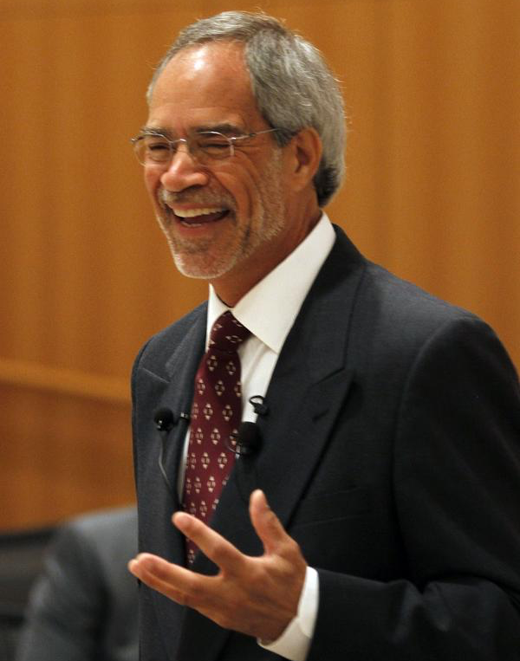
Robin Lawton is Leadership Strategist with C3 Excellence, Inc., a best-selling author and internationally recognized expert in creating rapid strategic alignment between enterprise objectives and customer priorities. Rob has over 30 years’ experience directing both strategic and operational improvement initiatives in industry, healthcare, government, education and international enterprises. His powerful but easy-to-understand principles and tools are outlined in his 5-star rated books (see Amazon.com), Creating a Customer-Centered Culture: Leadership in Quality, Innovation and Speed (1993) and Mastering Excellence: A Leader’s Guide to Aligning Strategy, Culture, Customer Experience and Measures of Success (2017). Some of his other books and articles are described at www.C3excellence.com and www.amazon.com .
Rob has been recognized for making profound contributions, equivalent to those of Dr. Edwards Deming, to leadership practices. Dr. Deming became well-known in the last century for his management principles and process improvement methods, particularly well-suited for industrial age enterprises. Rob’s work has similar importance for the service and knowledge-intensive enterprise of the 21st century, with special focus on new ways for understanding the voice of the customer and translating them into satisfying, innovative products and services that strengthen the enterprise’s mission, strategic objectives and daily work.

His North American clients include AT&T, American Honda, Motorola, Siemens, Raytheon, GE, General Mills, American Express, Ford, Eastman Kodak, U.S. Department of Defense, Mayo Clinic, Group Health Cooperative, Capital One, California State University, Blue Cross Blue Shield, Discover Card and many others. Clients from government include agencies from Alaska to Vermont. Rob also has been published in several countries and has numerous international clients, such as Siemens, ABB, Imperial Oil, Liebherr, Wolters Kluwer Health Pharma and others.

Rob is a thought-leading, humorous and engaging speaker. He has been ranked #1 of 88 speakers by an international organization and is regularly ranked “Best Speaker” at major conferences such as those sponsored by Chamber of Commerce, Japan Management Association, American Management Association, American Quality Institute, International ISO Conference, Minnesota Healthcare Association, American Society for Quality (ASQ), Association for Manufacturing Excellence (AME) and others.

Please contact Rob directly for information on public or in-house versions of this program:
Email: Rob@C3excellence.com Phone: 941-704-9888

